Furble Hunt

Form the three equations for each problem and find out how many of each furble there are.

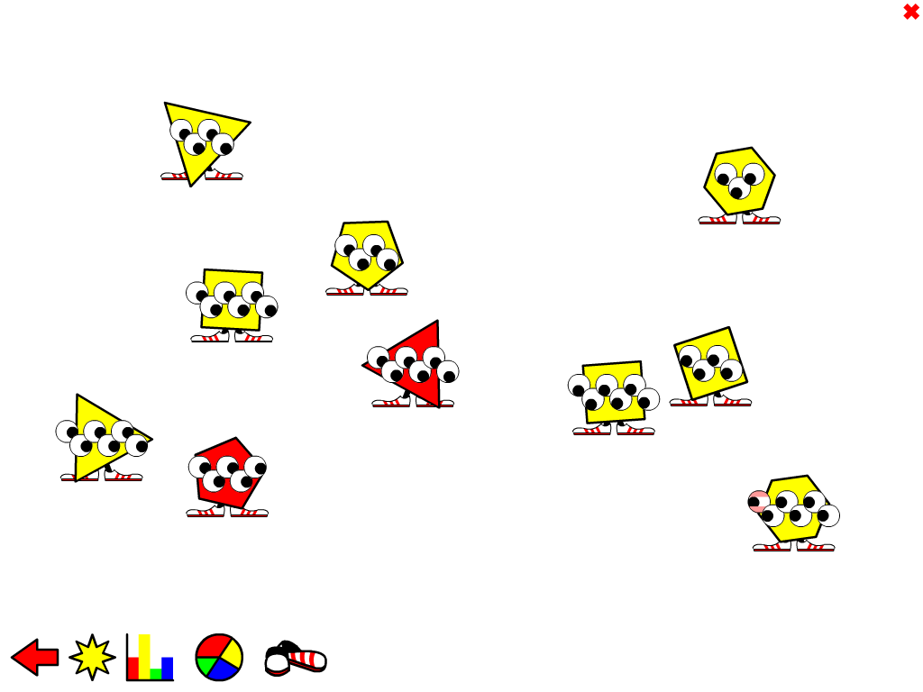 |  | Number of Furbles | 10 |  | x | y
 |  | Number of Eyes | 42 |  | x | y
 |  | Number of Sides | 34 |  | x | y
x of these | y of these
 |  | Number of Furbles | 11 |  | x | y
 |  | Number of Eyes | 45 |  | x | y
 |  | Number of Sides | 58 |  | x | y
x of these | y of these
 |  | Number of Furbles | 14 |  | x | y
 |  | Number of Eyes | 76 |  | x | y
 |  | Number of Sides | 58 |  | x | y
x of these | y of these

 |  | Number of Furbles | 14 |  | x | y
 |  | Number of Eyes | 52 |  | x | y
 |  | Number of Sides | 79 |  | x | y
x of these | y of these
 |  | Number of Furbles | 12 |  | x | y
 |  | Number of Eyes | 64 |  | x | y
 |  | Number of Sides | 44 |  | x | y
x of these | y of these
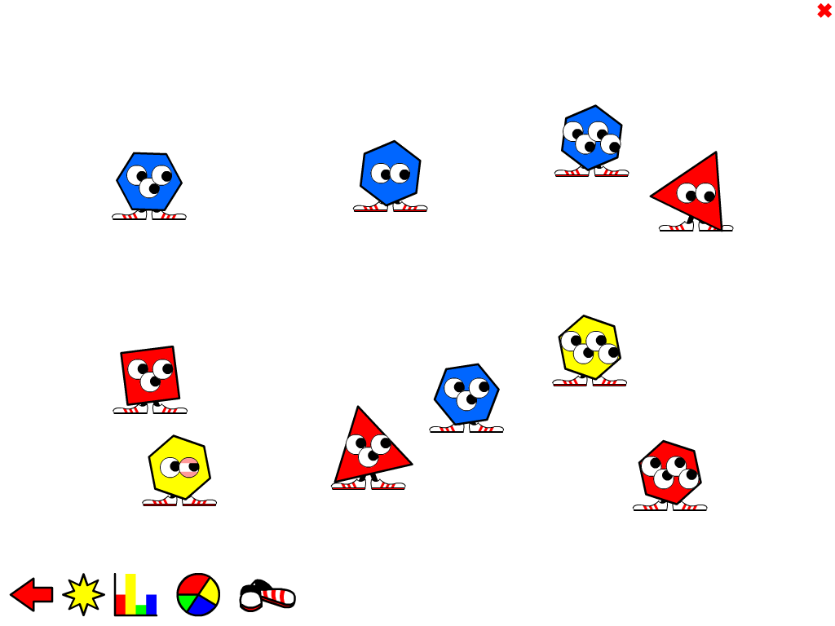 |  | Number of Furbles | 15 |  | x | y
 |  | Number of Eyes | 41 |  | x | y
 |  | Number of Sides | 68 |  | x | y
x of these | y of these

